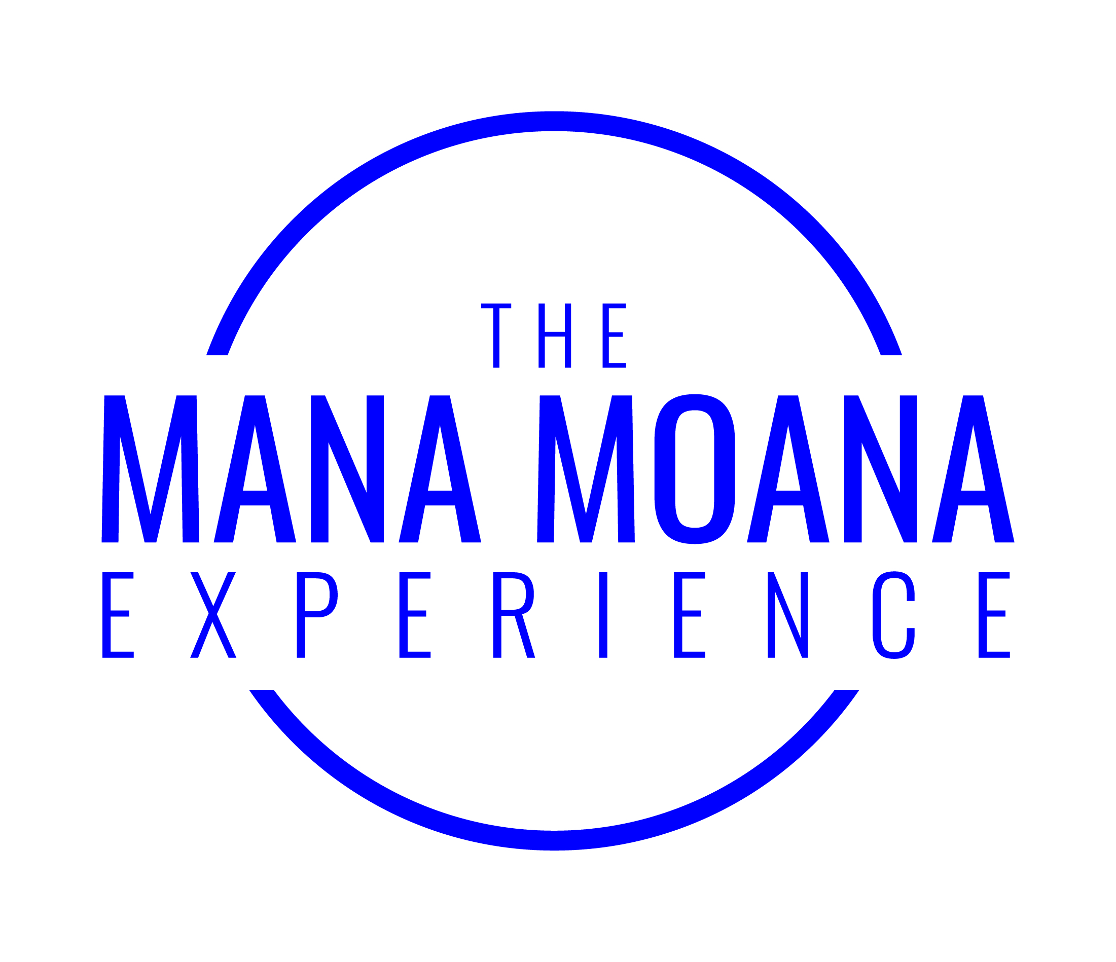

The Mana Moana Experience

Application Form 2020

Leadership New Zealand Trust
PO Box 5061, Wellesley Street, Auckland 1141
09 309 3749 / www.leadershipnz.co.nz

Talofa lava, Kia orana, Mālo ‘e lelei, Fakaalofa lahi atu, Ni sa Bula Vinaka,
Taloha ni, Talofa, Tēnā koe

Are you ready to take part in the Leadership NZ Mana Moana Experience?

Are you passionate about Pasifika leadership and making a difference as a leader for New Zealand? The Mana Moana Experience is targeted at mid-career Pasifika leaders. It is run over the course of eight months in the form of six live-in retreats lasting three days each (Thursday, Friday, Saturday). This is a commitment of 18 days (12 working days and 6 weekend days). Some peer coaching and small group contact is also expected in-between retreats.

Background Information: A brief introduction

The Mana Moana Experience is a unique programme for Pasifika leaders. The expertise and experience of Leadership New Zealand supports and complements a very specialist Pasifika programme which activates and harnesses the rich wisdom of Pasifika ancestral and indigenous knowledge. This has been created from the four-year postdoctoral research of Dr Karlo Mila (Leadership NZ Alumna 2013).

Mana Moana is focussed on helping Pasifika leaders
- Know themselves, where they come from, what their purpose and point of difference is
- Navigate complex and culturally distinctive worlds with skill and confidence
- Engage with and deepen cultural knowledge, strengthen their capabilities and add value by bringing their full selves into their professional lives
- Share experiences with a cohort of Pasifika leaders going through similar challenges and foster these lifelong relationships and networks of support through peer mentoring
- Access the inspiration of our most influential leaders by hearing their personal experiences first-hand
- Leverage their poly-cultural capital to scale up their leadership influence and impact and reap the diversity dividend for a better New Zealand.

Organisations and communities benefit through leaders coming back with a stronger sense of who they are – culturally, personally and professionally - and a greater sense of what they have to contribute. Mana Moana Leaders are more intentional, conscious, better able to deal with all kinds of complexity and ambiguity, stronger in their awareness of where they are coming from, able to capitalise on their own unique points of difference and deliver on the strategic objectives in their role for the whole organisation.

Information about Leadership NZ

The Leadership New Zealand Trust was founded in 2003 by a collective of New Zealand leaders drawn to developing and nurturing future generations of our nation’s leaders. We bring leaders from every generation and every sector of New Zealand society together: we connect them in a respectful, open and honest arena for dialogue, critical enquiry, reflections, skills development and deep learning. We challenge them with making a difference for the betterment of the communities within which they live, work and play.

The vision of Leadership NZ is to enrich New Zealand through active leadership in a connected community. It is our mission to build an exceptional leadership culture that develops and celebrates resilient, courageous and authentic leaders. Leaders who have a strong awareness of issues of significance for New Zealand; leaders who value diversity, engage in meaningful conversation, connect and work successfully across difference; and leaders who build and transform organisations, communities and effect positive social, economic and cultural change across society.

Our values are to be courageous, generous of spirit, inclusive, apolitical and innovative, to have integrity and to celebrate diversity. Leadership NZ has been around for 16 years and delivered its Leadership Programmes to over 500 leaders, and connected with thousands of New Zealand leaders through leadership events, social and professional platforms and community engagement initatives.

The Mana Moana Experience

Engaging with cultural legacies as a source of strength
A driving vision of the Mana Moana Experience is to harness the knowledge of our ancestors of the moana – the largest ocean in the world. It platforms and centres cultural resources, legacies and ways of knowing, understanding that these are fundamental and essential resources for optimal contemporary living and leadership.

It is premised on the idea that we are all connected by the ocean – as ‘Epeli Hau’ofa has advocated. As Pacific peoples we are linguistically, culturally, genealogically connected, as well as having our own unique ethnic-specific differences. Centuries of engagement with the largest ocean in the world has influenced all of our cultures. We have a seafaring and navigational culture of origin, the small islands we come from have prioritised sustainable relationships in order for harmonious societies to thrive, including reciprocal and respectful relationships beyond the social – with the land, sea, skies and spiritual realms. Our rich knowledge legacies have a lot to offer the world, leadership and New Zealand.

Shared Pacific language forms the basis of the programme. The Mana Moana Experience content is shaped by a drawing on a collection of over 70 indigenous words shared in at least 15 Pasifika languages, over 250 proverbs in multiple languages and shared mythological stories, metaphors, archetypes, values and wisdom from the largest ocean in the world. It is based on the postdoctoral research of the Programme Director, Dr. Karlo Mila.

This programme actively engages with our Pasifika worldviews, values, languages, proverbial knowledge, archetypes, narratives and beliefs. It is part of the Leadership NZ ethos to take and create the space for deep and meaningful conversation. The programme provides a uniquely respectful, open and honest arena for full debate, real challenge and deep learning about culture, legacy, self, the collective and Pasifika leadership in contemporary contexts.

Instead of forgoing, forgetting, sacrificing, acculturating and assimilating, to succeed in Western contexts, cultural resources are seen to be a source of advantage, pride, competitive edge, x-factor, complexity, cognitive flexibility, neuroplasticity, poly-cultural capital and diversity dividend.
Tackling the real issues
The Mana Moana Experience targets significant issues facing the Pasifika community, the Pasifika region and New Zealand, that we bear witness to. Many of New Zealand’s challenges are disproportionately experienced and borne by Pasifika children, young people, families and communities. This programme brings together a range of tools and information that assist Pasifika leaders with responding effectively to these challenges. The programme blends evidence, experience, experts, on the ground innovation and solutions to collective challenges and uniquely Pasifika approaches to problem-solving, including what we can do as individuals, families, communities and as a collective.

Each retreat involves talanoa with prominent leaders and guest speakers, workshops, and experiential activities. Over eight months, we connect this generation of leaders with significant leaders, changemakers for leadership dialogue and learning. These prominent leaders and subject matter experts candidly share their knowledge, personal leadership stories, challenges, learnings and experiences based on the “Chatham House Rule” approach to talanoa. The diversity of participants, speakers, topics and locations gives a variety of perspectives that create deep challenges, real learning and transformation in thinking and perspective.

Whenever there are social problems, there are already people acting on the problem in some way. Understanding those actions is part of developing effective strategies to resolve the collective problems we face. The Mana Moana Experience involves site visits to organisations and initiatives taking innovative approaches to identified social issues. The programme takes and explicit focus on solutions for Pasifika communities and New Zealand that must be tackled by an informed leadership. There is a focus on strategies that work in situations of scarce resources: solutions that are innovative, exceptional, effective and inspiring, holistic and sustainable.

Developing self, a commitment to reflection and personal growth
We challenge our participants to take themselves to their learning edge, to look at themselves as leaders, to develop their self-awareness, to develop their societal-awareness and to step forward in their organisations and communities to lead change for the better.

Through experiential individual and group activities, participants are challenged to reflect on their leadership views and practices, develop unique insights, build confidence, self-awareness and emotional intelligence. In addition, the programme introduces them to a wide range of tools and resources; including creative and design thinking methodologies, critical thinking, tools for increasing resilience and managing stress, leading through coaching and much more.

It is part of Leadership NZ’s kaupapa to stimulate and lead the bigger conversations that become the catalyst for change – personal change, organisational change, community change, societal change, regional change and global change. The Mana Moana Experience is central to this vision.

The Mana Moana Experience – Programme
The six retreats are held in a variety of locations throughout the Auckland – Northland region.

1. Va Tupuna: relationality – the core of Pasifika cultures
Leadership in the context of multidimensional relationships, roles and responsibilities. Spiritual, environmental, societal, community, church, family, extended family, homelands, and self. Pasifika indigenous practices and philosophy about va and relationality as well as practice strategies to strengthen, maintain and mend interpersonal relationships.

2. Va Fonua/fenua/fanua (land): Grounding in who we are
Indigenous leadership: our relationship with the land and environment, places of belonging, our own land-based identities, ethnic-specific responsibilities. Where have we landed: Marae stay. Pasifika peoples in relation to the Treaty of Waitangi, lessons we can learn from Maori leadership, relationships with homelands and engagement with the new localities or islands – Pasifika suburbs of Auckland. Grounding in self. Who am I? Where am I from? What do we need to thrive?

3. Va Moana (the great ocean) what we have in common – many migrations
Ancient navigating and way finding, common origins, collective migrations, historical legacies, ancestral genius, more recent migrations, migrant dreams, your own personal history and journey: Where we have been? Where are we going? Getting on board this vaka (boat) and the experience of a short journey on board a traditional voyaging vaka.

4. Va Tagata: The Realm of the Interpersonal – Politics, Power and Relationships
Political contexts, traditional and contemporary power structures, mana, roles and responsibilities, mobilizing, upward mobility, Pasifika leadership needs, prosperity. Pasifika church leadership challenges and opportunities. Effective communication strategies, prioritizing key issues, influence, networking, advocating, making systems work, making a difference. Negotiating cultural complexity effectively. Tackling critical issues at a local, city, national, regional, global level, political panels.

5. Va Ala/ara/hala: New pathways
New frontiers, trail blazers, forerunners, exploration, arenas beyond our experience. Site visits. Reaching into new realms, unchartered territory, strategies for success in these environments, learning from those who have been the ‘first’, exemplars, pushing ourselves beyond our own limits, comfort zones, learning edges. Reflecting on our own journeys. Finding pathways through adversity and challenges of the dark and unknown, resiliency and reckoning, surviving storms, forging new pathways. Who are we? Where are we going? Where is my journey leading?

6. Va Mokopuna: Ora/ola, life, well-being, the promised land
Visioning for the next generation. Health, abundance and wellbeing in all its fullness. Individual and collective well-being, sustainable self-care, community nurturing, wholeness, stewardship, full participation, seasons, cycles, optimal thriving, peak performance, full bodied dreaming, holistic and sustainable visions and practices, the next generation. Where do we want to be? How do we get there? What is my calling?

Candidate Requirements

Applications are invited from Pasifika** leaders who are residents of New Zealand and:

are talented leaders in their sector, with significant years of experience in their field of expertise

are committed to contributing to the creation of a better future for all New Zealanders

have demonstrated leadership capacity and have diversified experience

are prepared to challenge and be challenged

have an ability to re-evaluate their own thinking and action, and reflect

have the ability to build strong relationships and a desire to be a better-informed citizen

are able to commit (the programme spans eight months and attendance is essential)

have the capacity to travel (the programme is conducted throughout the Auckland - Northland region)

are committed to continuing their leadership growth through ongoing involvement in community service activities

are committed to becoming contributing Leadership NZ Alumni after completion of the programme.

Experience has shown that when candidates have a critical mass of the criteria noted above, they are likely to gain more from and contribute more to the learning experience. They are also more likely to transfer their learning to their organisation, community and beyond in a way that is mutually beneficial. It is important that all participants are present at each of the six retreats.

**We define Pasifika leaders as New Zealand residents who originate from, are descendants of, or who identify with a Pacific Island heritage, including Cook Islands, Fiji, Kiribati, Nauru, Niue, Papua New Guinea, Samoa, Solomon Islands, Tokelau, Tonga, Tuvalu, Vanuatu. If you identify with another Pacific Island nation and wish to apply, please contact us.

Selection of Candidates

Leadership NZ will select a group from diverse sectors of the Pasifika community. We invite applications from Pasifika leaders across AotearoaNZ. Shortlisting criteria will be based on an applicant’s previous experience and potential to provide leadership in the future; we are looking for Pasifika leaders who can make a difference. The programme will include a range of ages, gender, Pasifika ethnicities and sector representation.

Not-For-Profit, Community Sector applicants
As our Key Community Partner Foundation North provides funding for participants selected from the Not-For-Profit, Community Sector working in the Auckland - Northland region (Tamaki o Tai Tokerau).
We also have additional scholarship funding available for NFP/Community sector applicants from across the rest of Aotearoa.

Private and Public sector applicants
There are spaces available for candidates from the private and public sectors from across AotearoaNZ. In addition to the personal contribution, a full programme fee is payable for these successful candidates, and they need to cover any travel costs to attend each retreat.
Programme Fee $15,000 +GST

All applicants must have the full support of their organisation and their application must be signed by both the applicant and their CEO/Sponsor. Given the time commitment of the Mana Moana Experience and to be fair to the applicant, their family and employer, it is unlikely that the panel will select an applicant who is enrolled in a formal course of study.

The Mana Moana Experience – Application Process

Completed Application Forms must be emailed to manamoana@leadershipnz.co.nz.
Our overall approach is to accept enquiries and expressions of interest from July each year and we look to receive applications through to early September. Applications received after this are considered where appropriate to assist in building our diversity of participants for the programme. If you need more time to consider an application please contact us as soon as possible.

Formal interviews will be conducted by a diverse panel of Leadership NZ alumni, whanau and staff. Interviews will be conducted in months of September to November 2019. Successful applicants will be advised around mid-late November 2019. Timing will be advised during the interview.

Selection Process and Criteria

Participants will be people who have already demonstrated the potential that Pasifika communities hold, and people who, with additional support, mentoring, leadership development and the right exposure can go on to transform Pasifika communities and New Zealand as a whole. They will be mid-career established and emerging Pasifika leaders with a track record of service and the ability to make a greater impact with the right leadership support and development.

An interview panel will interview and assess the applicants. Successful applicants will be advised in December.
Assessment criteria will guide the selection of participants and will include:
- Achievement and Merit
- Service and Track record
- Professional pathways (career development)
- Pasifika leadership promise and fit to scope of programme

A. Achievement and Merit
Participant has already achieved some significant milestones or markers of achievement and recognition over the course of their lives that makes them an exemplar of Pacific success for their generation. Including, but limited to, academic achievement, business success, promotion, awards, scholarships, other leadership programmes, qualifications, promotions, peer recognition, entrepreneurship, social enterprise, charitable events, recognition in traditional Pasifka or church hierarchies, sporting achievements, creative or cultural recognition and so on.

B. Service – track record (impact, influence, altruism)
Participant already has a track record of service or impact/influence at a community and/or national and/or regional level. This could be for Pasifika-focused service but is not limited to that. It may be through professional/personal/community/cultural/creative/media channels but the impact through whichever vehicle has been right for that person is clear. They have accumulated some kind of mana and recognition for the contributions that they have made and it is not hard to make the case that the drivers have an altruistic aspect, a heart for community, positive change and service to the greater good. With the right support and leadership development, the potential for them to make more of an impact is exciting.

C. Professional pathways (career/community development)
Participant has built an excellent reputation for themselves and has a promising career/community development pathway in front of them. With the right support, their opportunities for acceleration, influence, mobility, impact and leadership are significant. They have strong mid-career qualifications/training/work experience and life/experience that provides a solid platform for more senior opportunities to be validly available to them.
D. Pasifika Leadership Promise and fit
These are Pacific leaders who already embody and uphold the vision of “Pacific communities working and thriving together” in their own right, and yet who, with the right leadership and development support skills, will capably advance this vision to the next level with passion, purpose and enthusiasm. The life experiences, skills, competencies and development needs of the participant fits well with the scope of the programme. They will respond well to the calling that Pacific identity is a core part of strong leadership and fulfil the promise that strong Pacific leadership is a source of competitive advantage for the individual, families, organisations, communities and New Zealand.

Alongside these ranked criteria will be considered a matrix of factors to create the right group: ethnic-specific representation, diversity across sectors, skill-mix, demographic diversity, gender balance. There are three intakes of participants from 2018 – 2020, and applicants are encouraged to apply again if unsuccessful.

Expectations and Commitments:

Personal Fee: Every participant is expected to make a personal contribution of $600 +GST as a personal commitment and investment to their leadership development.

Not for Profit, Community Sector applicants: Mana Moana Experience programme fee costs are fully covered for successful Not For Profit/Community sector applicants, including travel and accommodation costs.

Private and Public sector applicants: There are spaces available for candidates from the private and public sectors. In addition to the personal contribution fee, successful candidates are expected to cover their travel and accomodation costs, and a full programme fee will be payable Programme Fee $15,000 +GST.

Participants will be provided with a journal, and information packs are sent out with reading material at least two weeks prior to each retreat, and there is an expectation that participants come fully prepared for each retreat.

Dates for 2020 retreats are outlined below and posted on the website as part of the application process to enable potential participants to determine if they will be able to schedule their activities to meet the attendance requirements. Confirmation of being able to meet the attendance requirements will be discussed during the interview process.

The programme spans eight months of the year (18 days that require attendance). The retreats are three-day blocks.

Dates for 2020 Mana Moana Experience are:

Opening Retreat - Va Tupuna | March, 5th – 7th | Auckland
Retreat Two - Va Fonua | April, 30th – 2nd May | Northland (Te Tai Tokerau)
Retreat Three - Va Moana | June, 25th – 27th | Waiheke Island
Retreat Four - Va Tagata | August, 6th – 8th | South Auckland
Retreat Five - Va Ala | September, 17th – 19th | Auckland
Retreat Six - Va Mokopuna | October, 29th – 31st | West Auckland

Attendance is mandatory for all the retreats. If a participant cannot attend the retreat, they may not be able to participate in (or graduate from) the programme. If a participant is unable to attend a retreat due to an emergency, the Programme Manager should be contacted as soon as possible. Please note that missing half days and late arrivals/early departures are discouraged.

Leadership NZ will review the viability of an individual’s continued participation in the programme if absences are such that the attendance requirement is at risk. There is an expectation that chosen participants will commit to the programme and delegate work responsibility around the confirmed programme dates. Participants who are unable to achieve this are encouraged to withdraw prior to the commencement of the programme.

Early notice of such withdrawal (and possible deferment to a later year when the attendance requirements can be fulfilled) will enable one of the ‘reserve’ candidates to be offered a position in the programme. It is, however, programme policy not to replace withdrawals once the programme year has commenced.

By accepting a place on the Mana Moana Experience, a participant enters into a contract with Leadership NZ. As Leadership NZ is not able to replace a participant who withdraws from the programme once it has commenced, no refund will be given if a participant withdraws after the programme has commenced.

By completing this application, you are indicating that the Leadership NZ Trust vision, mission and values are meaningful to you and that you are prepared to take another step in your leadership journey.

We welcome your application and look forward to engaging with you through the selection process.

In completing this application, I have (please tick)

Read through and understand all the relevant information and FAQs

Checked that I can attend the 2020 retreat dates

Signed sections 7 & 8

1. Personal Details

Full Name (First name, Middle name(s), Surname)
Your Title name (if applicable)
Preferred Name
Date of Birth
Gender
Ethnicity
Iwi Affiliations (if applicable)
Language/s Spoken
Contact Details
Mobile
Work Phone
Home Phone
Work Postal Address
Home Postal Address
Work Email
Home Email
Preferred Email Contact

Personal Interests/Hobbies
How did you hear about the Mana Moana Experience? (i.e. CEO?employer, website, colleague/friend, Foundation North, LNZ Trustee, LNZ Alumnus, MM Alumnus, magazine etc.)
Have you attended any Leadership NZ events? If so, which one/s and when?

2. Employment/Experience

Current Employer/Organisation
Current Position
Length of Employment
Brief Description of Role (responsibilities, challenges, budget, staff, etc)
What do you consider to be your highest career achievement to date?
List any career related special awards/honours/acknowledgements?
In what ways has your working life contributed to the advancement of Pasifika peoples (if any)?
What do you consider to be your highest career achievement to date?
Previous employment (from most recent) covering at least the last 10 years
Employer
Title/Responsibility
Date Employed
Reason for Leaving
Employer
Title/Responsibility
Date Employed
Reason for Leaving
Employer
Title/Responsibility
Date Employed
Reason for Leaving
Employer
Title/Responsibility
Date Employed
Reason for Leaving
Employer
Title/Responsibility
Date Employed
Reason for Leaving

3. Education

Education History (from most recent)
Institution
City/Town
Years From/To
Qualification
Major Studies
Institution
City/Town
Years From/To
Qualification
Major Studies
What was your main reason for undertaking this course of study?

Extracurricular/leadership activities during education?
List any education-related special awards/honours/acknowledgements?
Leadership training/courses/subjects you have completed via studies, employment or voluntary work?
Will you be enrolled for any training/studies next year? If yes, please specify.

4. Community Activities and Service

How do you serve communities, ethnic groups, Pasifika peoples, New Zealand, your country of origin or Pacific region?
What do you consider to be your most important and impactful community achievement and why?

What are your current major community interests? Please list, in order of importance to you, up to three community, civic, religious, social, cultural, sport, arts or other organisations/collectives/groups of which you are, or have been a member/volunteer, indicating any positions of responsibility. This can include major events that you have organised or been involved with for community benefit. You can include informal as well as formal community involvement, including extended family obligations and service.
Organisation / Event / Achievement
Purpose/reason for involvement
Dates of involvement
Position(s) Held

Organisation / Event / Achievement
Purpose/reason for involvement
Dates of involvement
Position(s) Held

Organisation / Event / Achievement
Purpose/reason for involvement
Dates of involvement
Position(s) Held

How much time each month do you currently commit to the above organisations or equivalent activities?
What have been the major barriers to you becoming involved, or more involved, in community activities to date?
What interests you most, with regard to community transformation?

5. Awareness of Pasifika Issues

Which Pasifika issues are you most passionate about and involved in?
What do you feel are the two most significant problems facing Pasifika communities today?
What do you feel needs to be done about one of these issues?
What are the two most exciting opportunities available to (choose one) Pasifika communities or the Pasifika region or New Zealand?
What do you feel needs to be done to develop one of these?
6. Personal Insights

What are your reasons for applying for the Mana Moana Experience?
What do you bring (i.e. particular strengths/experiences) to the Mana Moana Experience?
What would you most like to develop (i.e. particular strengths/experiences) in yourself through this opportunity?
How do you expect Pasifika peoples, your ethnic-specific community, country or your local community to benefit from your successful completion of the programme?
How do you expect your organisation and/or the people it serves to benefit?
Which leaders are you most inspired by and what is it about them that inspires you?
How would others describe you?
Why do you think you should be selected?
What would you most like to learn?

7. Employer Support

To be completed and signed by the applicant’s CEO/Sponsor.
Choose One:
For Not-For-Profit, Community Sector Applicants:
This candidate has my full support to participate in the Mana Moana Experience which will run from March 2020 to October 2020. I am aware of the time commitment (18 days total, 12 week days, 6 weekend days and some project time). I understand that this programme is fully funded and thus releasing the participant from 12 working days is considered ‘support in kind’.
For Private Sector, Public Sector Applicants
This candidate has my full support to participate in the Mana Moana Experience: which will run from March 2020 to October 2020. I am aware of the time commitment (18 days total, 12 week days, 6 weekend days and some project time) and the Programme Fee ($15,000 +GST)

Name
Position Held
Organisation
Date
Signature

8. Personal Commitment

To be completed and signed by the applicant.
I have read and understood the information provided, including the FAQs document.

I understand the goals and time commitments of the Mana Moana Experience (18 days total, 12 week days, 6 weekend days).

I understand that if selected, I will devote the required time, and will pay the Personal Fee ($600 +GST) prior to commencing the programme in March 2020. I agree to conduct myself in a manner consistent with the Leadership NZ values and will not engage in any behaviour during the Mana Moana Experience that may damage the reputation of Leadership NZ. I understand that I am committing myself to lifelong membership of the Leadership NZ Alumni and increased involvement in the community upon graduation from the programme.
Date
Signature

9. Referees

Please list two people (other than your CEO/Sponsor) who are able to comment on your leadership performance and potential.
Name
Position Held
Organisation
Relationship to you
Length of time known
Phone Number
Email Address
Name
Position Held
Organisation
Relationship to you
Length of time known
Phone Number
Email Address

10. Privacy Policy

The personal information provided by you to Leadership NZ will only be used for the purposes for which it was collected. Personal information and email addresses will not be disclosed to other organisations and measures will be taken to prevent unauthorised access or disclosure other than with your consent. As part of Leadership NZ’s commitment to evaluation of the impact of the Mana Moana Experience, we do from time to time use participants’ feedback from throughout the year. No personal information is disclosed to other organisations as part of this evaluation.

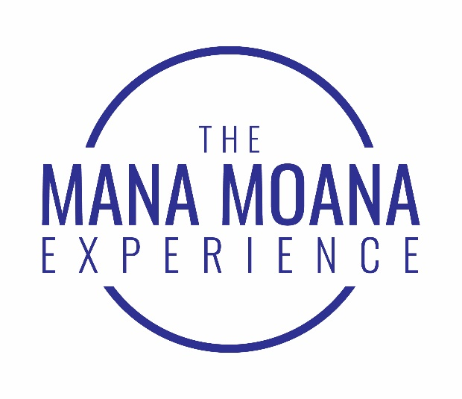
2020 Programme Dates
2020 Dates | Days | Retreat | Theme | Location
Thu 5th – Sat 7th March | 3 | 1 | Va Tupuna: Relationality – the core of Pasifika cultures | Auckland
Thu 30th April – Sat 2nd May | 3 | 2 | Va Fonua/fenua/fanua (land): Grounding in who we are | Northland
Thu 25th – Sat 27th June | 3 | 3 | Va Moana: (The great ocean) Many migrations | Waiheke
Thu 6th August – Sat 8th August | 3 | 4 | Va Tagata: The Realm of the Interpersonal – Politics, Power and Relationships | South Auckland
Thu 17th – Sat 19th September | 3 | 5 | Va Ala/ara/hala: The Journey | Auckland
Thu 29th – Sat 31st October | 3 | 6 | Va Mokopuna: Nurturing Leadership Legacies | West Auckland

Additional Dates (Please note that there could be minor amendments to these programme dates, and flexibility may be needed)
Thu 5th March |  | Mana Moana Experience Launch | Auckland
Early July |  | NZ Leadership Week event | Auckland
August/September (tbc) |  | Sir Paul Reeves Memorial Lecture | Auckland
Saturday 31st October |  | Mana Moana Experience Graduation | Auckland
Tbc |  | LNZ Alumni Retreat | Tbc
Tbc |  | MM 2020 Reunion Retreat | Tbc

